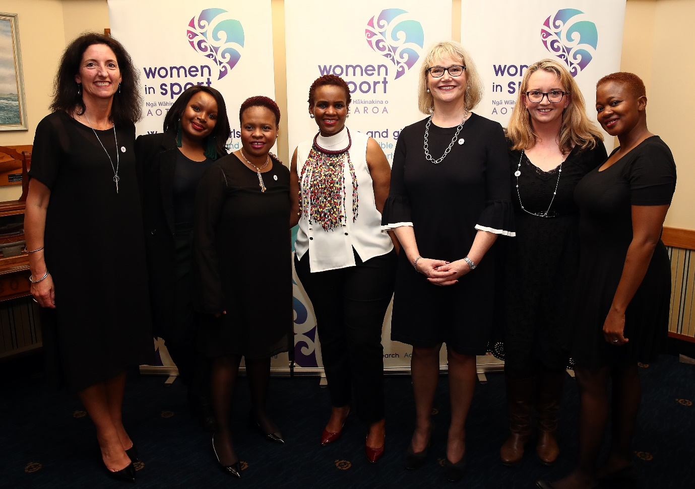

Bid Pack:
IWG Secretariat &
World Conference
2022 - 2026

BID APPLICATION

Host of the IWG Secretariat 2022 – 2026 & 9th IWG World Conference on Women & Sport (2026).

Please submit an official letter outlining your Expression of Interest (EOI) by email to:
IWG Secretary General Rachel Froggatt (rachel@womeninsport.org.nz / +64 (0) 27 546 5836)
Deadline: not later than 30 September 2020.

Please submit your completed bid application by email to:
IWG Secretary General Rachel Froggatt.
Deadline: not later than 31 March 2021.

Between 1 April 2021 and the IWG AGM, each bid will be reviewed by the IWG Bid Steering Committee. The IWG reserves the right to ask questions or seek clarity from bidding host nations during this time and may ask short-listed bidders to present their case by video call (to be determined by 30 April 2021).

The IWG Bid Steering Committee will present a recommendation to the IWG Global Executive for decision at the IWG AGM 2021, taking place in early June 2021 (date tbc pending confirmed location).

The successful host of the IWG Co-Chair, IWG Secretariat and 9th IWG World Conference on Women & Sport will be informed immediately post the IWG AGM 2021. In collaboration with IWG New Zealand, a public announcement will be made shortly after. The new host nation will be invited to attend, present and partake in all parts of the 8th IWG World Conference, 5 - 8 May 2022 in Auckland, New Zealand.

GENERAL OVERVIEW

The International Working Group (IWG) on Women & Sport is the world’s largest network dedicated to ‘empowering women and girls and advancing sport’. It is fully aligned to the 17 United Nations Sustainable Development Goals, in particular SDG 5: ‘Achieve gender equality and empower all women and girls.’ For over 25 years, the IWG has advocated for gender equity in global sport and physical activity. It continues to lead from a place of respect within the sport and physical activity system, releasing research and advocating amongst key global stakeholders such as the United Nations, UNESCO, and the International Olympic and Paralympic Committees. Every four years since 1994 it has staged the IWG World Conference – the largest global gathering on gender equity in sport and physical activity. The IWG developed and remains guardian of the Brighton plus Helsinki 2014 Declaration on Women & Sport, which now has almost 600 Signatories. It produces the IWG Progress Report, tracking the progress of the Signatories and to date, providing the only collective report on these global bodies.

The IWG Secretariat & Conference 2018 – 2022 quadrennial is being hosted by Aotearoa New Zealand, with Women in Sport Aotearoa (WISPA) as global delivery agent (referred to as IWG New Zealand throughout this document). WISPA is a not-for-profit organization. Its vision is: ‘women and girls are valued, visible and influential in sport’. It works across Aotearoa New Zealand, delivering advocacy, change leadership and research activity. In addition to setting and delivering on a 4-year strategy for the IWG, WISPA will also host the 8th IWG World Conference in Auckland, New Zealand, 5 – 8 May 2022.

Every four years the IWG has held an IWG World Conference on Women & Sport in a different region:

YEAR | CITY | COUNTRY | PARTICIPANTS
1994 | Brighton | United Kingdom | 280
1998 | Windhoek | Namibia | 400
2002 | Montreal | Canada | 550
2006 | Kumamoto | Japan | 700
2010 | Sydney | Australia | 500
2014 | Helsinki | Finland | 800
2018 | Gaborone | Botswana | 1200
2022 | Auckland | New Zealand | TBC

In order to sustain the momentum created and track future progress, the IWG Global Executive - the leadership body for the network - is now accepting bids from countries or organizations interested in:

- The position of IWG Co-Chair in 2022 – 2026;
- Hosting the IWG Secretariat from September 2022 – 2026; and
- Hosting the 9th IWG World Conference on Women and Sport in May/June 2026.

Ideally, these three opportunities should be taken on by a single country or organization. However, a joint bid from more than one organization / country working together may also be considered as a possibility. Joint bids are to be outlined in your application with details of organizations and how the partnerships work. Candidates bidding for hosting must secure funding for support of all the functions.

THE INTERNATIONAL WORKING GROUP (IWG) ON WOMEN & SPORT

https://iwgwomenandsport.org/

Facebook: https://www.facebook.com/IWGWomenSport/
Twitter: https://twitter.com/iwgwomensport
Instagram: https://www.instagram.com/iwgwomensport/
LinkedIn: https://www.linkedin.com/company/iwg-women-sport
YouTube: https://www.youtube.com/user/IWGWomenSportNetwork

Vision

A sustainable sporting culture based on gender equality that enables and values the full involvement of girls and women in every aspect of sport and physical activity.
Mission

Empowering Women and Girls - Advancing Sport.
The mission is accomplished through the action and influence of the IWG as a catalyst, engaging governmental and non-governmental organizations and individuals for the advancement and empowerment of women and sport globally.

Values

- Collaboration
We place importance on international collaboration, enabling us to achieve our vision through consultation with stakeholders and incorporate their feedback into our decision-making.

- Inclusiveness
We value diversity through the provision of equal opportunity, voice, and choice for all people regardless of nationality, ethnicity, religion, gender, disability, age or sexual orientation.

- Transparency
We are transparent and accountable in all our operations and decision-making processes including management and governance.

- Outcomes focus
Recognizing the importance of appropriate processes, we aim to achieve measurable outcomes in keeping with our mission and vision.

Purpose

Use the power of sport and physical activity to drive positive social changes for women and girls and improve their health and wellbeing.

Goals

- Leadership & Advocacy: Influence gender equity agenda
- Capability & Knowledge: Facilitate positive behavioral change
- Value & Visibility: Leading advocate for women and girls
- Connections & Engagement: Support an empowered global network

Outputs

Please refer to the IWG Strategic Plan 2018 – 2022 for a full picture of IWG’s intentions of over this quadrennial. This Plan was developed by IWG New Zealand in consultation and under the direction of the IWG Global Executive. The new host will be required to update this Strategic Plan for 2022 – 2026.
SECTION 1 – POSITION OF IWG CO-CHAIR(S)

The IWG is led by two co-chairs. One is from the new host country; they will take overall responsibility and leadership for delivery of the IWG Secretariat & World Conference 2022 - 2026. The other will be from the immediate past host country (ideally the co-chair that led the IWG Secretariat & World Conference 2018 - 2022). If the latter is unavailable, a suitable candidate shall be chosen by the IWG Global Executive according to policy. Between them, the co-chairs will decide on a division of labour.

Skills, Competencies, Knowledge Required

The co-chair in the bid application should possess the requisite influence within the host country and/or internationally in order to raise the profile of the IWG’s work, seek funding, as well as lead and promote the IWG’s initiatives globally and locally. She/he should also have the support of key stakeholders such as government organizations and non-government organizations locally to support successful delivery.

The following skills, competencies and knowledge are required of the co-chair:
- Ability to add value to the design and implementation of strategies for change at a global level.
- Knowledge and understanding of the structure and politics of the international sport and physical activity movement.
- Capability to influence senior decision-makers within political, governmental, non-governmental and sport and physical activity domains.
- Ability to network in person and remotely and develop and nurture relationships with individuals and organizations within and beyond the international sports and physical activity movement.
- Availability and capability of representing the IWG at meetings and conferences globally and locally.
- Skills to operate at a strategic and leadership level with other sport and non-sport agencies.
- Ability to lead and implement partnership strategies among varying agencies, in particular multi-sport games (i.e. the Olympic and Paralympic Movement) and international federations.
- Philosophy and demonstrated commitment to the advancement of girls and women’s sport and physical activity.
- Proven track record of leadership.
- Experience in issues related to sport and physical activity policy. Human rights knowledge welcome.
- Experience in organizing national/international events.
- Proven communication skills (written and oral) in English.
- IT/Internet literacy and/or willingness to use new technologies (Microsoft Office, applications, email, social media applications, dropbox, etc.).

REQUIREMENT: Bidder to submit the following as an attachment to the bid document:
- Candidate’s Curriculum Vitae (CV).
- Personal statement of purpose for serving as IWG co-chair for 2022 – 2026.

SECTION 2 – IWG SECRETARIAT (September 2022 – October 2026)

- Ideally, the IWG Secretariat 2022 – 2026 shall be based in the same country as the 9th IWG World Conference on Women & Sport 2026. The IWG Secretariat manages the day-to-day work of the IWG globally and provides support for all of its activities and initiatives. The Secretariat is the critical link between the IWG Global Executive, members of the network, key stakeholders in the women and sport and physical activity movement, the wider network and the public at large. In this respect communication in English is essential and language skills in French and Spanish are also desirable. The IWG Secretariat will appoint an IWG Secretary General to lead the team to deliver for IWG.

- The IWG Secretariat will support the work of the IWG globally by creating and implementing the IWG Strategic Plan 2022 - 2026. As an example, see the current IWG Strategic Plan 2018 – 2022.

Key components include:

  - Promote, support and monitor the progress and implementation of the Brighton plus Helsinki 2014 Declaration on Women & Sport and proactively add value to the work of the Signatories.
  - Strengthen IWG strategic partnerships with the UN and key agencies (i.e WHO), governments, NGOs and special interest groups; network and work to influence the gender equity agenda.
  - Share global best practice, innovations and research (including data collection, analysis and preparation of the IWG Progress Report for presentation at the 9th IWG World Conference).
  - Facilitate the IWG’s contributions to forums and conferences worldwide.
  - Share research and information with media and key influencers, advocating for gender equity.
  - Maintain and grow awareness and recognition of the new IWG brand mark launched 2019.
  - Disseminate information regarding the women and sport and physical activity movement via the IWG’s communication channels: its multi-lingual website (www.iwgwomenandsport.org), Catalyst electronic newsletter and global database, social media channels and other means.
  - Act as steward and delivery agent of the 9th IWG World Conference on Women and Sport.
  - Ensure sustained development of the IWG across the four years in a way that is in line with its vision, mission, values, purpose and goals. Organize the IWG Global Executive AGM annually.
  - Maintain the IWG’s database and resources; manage all policies; oversee the Bid 2026-2030.

Also, during the current quadrennial, the IWG Global Executive tasked IWG New Zealand to develop a global ‘Insight Hub’ as a tool to engage and support a global ‘Community of Action’. The approved plan for this can be sought from IWG New Zealand. The work is intended to go live before the end of 2020. The IWG Global Executive asks that bids outline how this would grow and evolve, 2022-2026.

REQUIREMENT: Bidder to submit the following within the bid document:
- A short summary of the host organization, outlining its credentials as a potential host for the IWG Secretariat 2022 – 2026. It should include background, vision, mission and aims, day-to-day activities, scope of operations, source(s) of funding and contact information including organization website and mail address, name of contact person and his or her email address and phone number.
- A short statement purpose for serving as host the IWG Secretariat 2022 – 2026 should be included.
>> SECRETARIAT ASSESSMENT CRITERIA

- Commitment/ideology and resources: Adequate financial support for the Secretariat’s four-year term must be secured by the bidding organization and shown in the bid. The IWG Secretariat must also commit to supporting the IWG fulfil its key responsibilities (e.g. mission, purpose and goals).

- Support from key national decision-making bodies, both government and non-government, impacts the success of the IWG Secretariat’s work. Commitment may be manifested in a variety of ways, for example: goods and services in kind provided to the IWG Secretariat, financial support for the activities of the IWG Secretariat or assistance with respect to public relations and the promotion of the IWG’s work nationally, regionally or internationally. The bidder should demonstrate support.

- Multi-agency involvement: It is recommended that the IWG Secretariat work closely with key national/regional organizations during the four-year term. This type of cooperation can help to secure support, facilitate the Secretariat’s work, and ensure optimal impact of the IWG Secretariat’s term in the host country. The bidder should show how it intended to leverage partner agencies.

- Legacies/Impacts: The impact of hosting the IWG Secretariat may be social, cultural and economic. Candidates are encouraged to plan for the lasting effect of the IWG Secretariat’s term that will benefit women and sport in the host country and the future of the IWG and showcase in the bid.

- Language capacity: The ability to effectively communicate in English is a minimum requirement of the IWG Secretariat. French and Spanish language capacities are also looked upon very favorably.

- Financing: Budget for the IWG Secretariat should include but not be limited to:

  - Full time staff members for the four-year period, depending on your needs and IWG work load.
  - Additional staff when needed (i.e. contractors, outside agencies, etc).
  - Administrative costs, office space and supplies (including all equipment, desks, chairs etc.).
  - Travel (attendance at IWG annual meetings, relevant conferences and/or other meetings).
  - IWG website and ‘Insight hub’ technology maintenance and content creation and publicity.
  - Conducting the quadrennial IWG Progress Report on global developments in women and sport.
  - Promoting the previous conference legacies whenever possible (i.e. Gaborone, Helsinki, etc).
  - Information Technology Services including software and hardware (computers/internet access, printers/ photocopiers, online meeting capabilities, file sharing, mass emailing software, etc.).
  - Accounting services.
  - Legal services.

- Collaboration: Please advise how you would intend to collaborate with IWG New Zealand between May and September 2022, for smooth transition of the IWG Secretariat. It is recommended that your office plans to shadow IWG New Zealand immediately after the 8th IWG World Conference.

SECTION 3 – WORLD CONFERENCE ON WOMEN AND SPORT HOST AND ORGANIZER

The IWG World Conference on Women & Sport is held every four years and is the highest profile event staged by the IWG and the largest independent conference of its kind in the world. The event is action-oriented, and its focus is on realizing change and considering the synergies between sport and physical activity, the women’s movement and other entities interested in women’s empowerment. These World Conferences have a unique purpose and reporting function; however, they are also a milestone in the four-year IWG Secretariat journey and therefore should not be considered as a “stand-alone” event.

The conferences build on the success of the previous event and are linked by a common “change” theme. Between 500 – 1000 (or more if capacity allows) decision-makers, administrators, coaches, scientists and athletes share success stories and determine strategies and action plans for the future. IWG New Zealand intends to stage the 8th IWG World Conference as a full physical-digital hybrid, recognizing the impacts of COVID-19 on travel and budgets. This is likely to set a future precedent.

>> WORLD CONFERENCE ASSESSMENT CRITERIA

- Commitment/Ideology and Resources: Support from key national decision-making bodies, both government and non-government, has been proven to contribute significantly to the promotion of the conference and its success. It also impacts on the credibility of the IWG globally. Commitment and support may manifest in a variety of ways, for example: past initiatives focusing on women and sport and physical activity, financial support for the activities of the candidate organization, support for national / international events or initiatives aiming to enhance opportunities for women in sport. The host organization must guarantee financial support for the 9th IWG World Conference in 2026.

- Multi-agency involvement: It is recommended that the organizers work with key national/regional organizations to secure support, design programming, facilitate the effective implementation of follow-up action steps and ensure optimal impact of the conference and work of the IWG globally.

- Legacies/Impacts: Impact of the conference may be economic, social or cultural. Candidates are encouraged to plan for anticipated impacts that benefit women and sport and physical activity in the host country and the future of the IWG. Consider what change the host organization is driving.

- Location: Geographical accessibility and balance in relation to past World Conferences are both important. The intention behind these conferences is to mobilize action worldwide. Host regions in the past have experienced particular benefits and the varied locations of the World Conferences have allowed for participants from many different regions of the world to take part. You will need to provide the following information in your bid document:

  - Proposed host city and dates for the 9th IWG World Conference on Women & Sport 2026
  - Proposed conference venue (location, capacity and facility information, accessibility, etc.)

- Accessibility: The conference site should be as easily accessible and comfortable as possible for all participants. Candidates should aim to offer a safe and secure environment. The IWG World Conference must fully accessible to the disabled delegates, physically and via the presentations.

- Affordability: This event aims to attract a diverse profile of participants from both developed and emerging countries. In this respect, a wide variety of accommodation options is necessary and participant costs (registration, meals, social) should be kept as low as possible. Additionally, efforts should be made to offer grants and financial assistance, making it possible for delegates from emerging countries to also attend. In addition, there may be a fee structure offered with discounts for delegates from emerging countries. Young adults also represent an important group and efforts should be made to increase their possibilities to attend. As mentioned, IWG New Zealand intends to stage the 8th IWG World Conference as a full physical-digital hybrid, recognizing the impacts of COVID-19 on travel and budgets. This is likely to set a future precedent regarding digital ticket costs.

- Facilities: The conference facilities should be accessible and easily reached. Meeting room capacities should include: plenary sessions of at least 1000 participants; several, simultaneous, small group sessions; poster presentation space; audio-visual aids, and live support for multiple languages.

- Accommodation: Anticipated hotel rates in US DOLLAR.

- Transport: Provide information on the following:

  - Nearest international airport(s).
  - Anticipated method(s) of transportation to be used by conference delegates between the airport and the conference hotels and during their stay.

- Finances: The IWG does not have a budget to support the 9the IWG World Conference. The organizer must secure adequate financial resources and must submit as follows:

  - Details on how the organization plans to raise the funds necessary to hold a conference of this size in terms of specific support and timing.
  - Details on any governmental support and/or sponsors who have committed to support the application.
  - Details on any other anticipated revenue streams.
  - Estimated registration fee to be charged and what it will include.
  - Draft budget, listing anticipated income and expense items.

- Translation: Simultaneous translations of the plenary sessions and workshops into English, French and Spanish, as well as regionally appropriate languages, is highly recommended in order to ensure active participation from a linguistically diverse group of participants. Sign language options needed.

- Human resources: In addition to the IWG Co-Chair and Secretariat, personnel dedicated to the conference planning are required. Volunteers/support staff during the event highly recommended.

- Background information: to be provided in the bid document

  - Description of the organization’s experience in the international women and sport and physical activity movement and related national/international events or initiatives.
  - Organization’s statement of purpose for serving as host the for hosting the 9th World Conference on Women & Sport.

- Conference dates: Traditionally IWG World Conferences on Women & Sport have been held in either May or June over 4 days and have gathered up to 1,200 participants from around the world for several days of exchange and discussion.

- Themes: In cooperation with the IWG Global Executive, the host selects a conference theme and prepares the conference program, focusing on salient issues and the needs of participants. To date, each of the previous hosts back to 1994 has created a theme using the word “change”. The monitoring role of the IWG is key to the conference development and the information on progress, success and lessons learned that is continually collected by the IWG Secretariat is made available to all participants. The IWG is a critical link between representatives of international, regional and national organizations interested in women and sport issues and the World Conferences are an important opportunity for interaction and discussion.

- Collaboration: kindly provide information on possible collaborations as:

  - Status of support for the organization’s bid to host the 9th IWG World Conference on Women and Sport by national, regional, Government and city authorities and/or sports organizations;
  - Key national/international organizations, networks or other bodies with which the organization intends to collaborate with in order to carry out a successful Conference;
  - How you would intended to collaborate with the New Zealand Secretariat between May and September 2022, for smooth transition of the IWG World Conference IP and knowledge.

REQUIREMENT: a bid document expressing the bidder’s vision for the IWG World Conference and its answer to the above. Express how bidder will move the global women and sport movement forward.

Questions:

If needed, applicants may be asked additional questions regarding their bid application.
Contact IWG Secretary General Rachel Froggatt (rachel@womeninsport.org.nz / +64 (0) 27 546 5836).

